**WEATHER FORECASTING APP**

**A MINI PROJECT REPORT**

***Submitted By***

**Group : G3**

CHETAN AJMANI , 2410990215

BHAVYA JAIN , 2410990194

AAYUSH YADAV , 2410990163

***In partial fulfillmet for the award of the degree***

***Of***

**BACHELOR OF ENGINEERING**

**In**

**CSE(Computer Science Engineering)**



**CHITKARA UNIVERSITY**

CHANDIGARH-PATIALA NATIONAL HIGHWAY

RAJPURA(PATIALA) PUNJAB-140401(INDIA)

**NOVEMBER 2024 (1ST YEAR)**

**ABSTRACT**

This project details the creation and deployment of a weather forecasting mobile application aimed at delivering users timely, precise weather data. Key features encompass hourly and weekly forecasts, severe weather alerts, and GPS-based local weather updates. Designed with a user-friendly interface, the app caters to both casual users and professionals, ensuring easy accessibility. By incorporating predictive analytics and real-time data integration, the application significantly aids decision-making for outdoor activities, travel planning, and emergency preparedness. Looking ahead, future enhancements will focus on improving prediction accuracy and expanding global coverage. This will ensure even more reliable and comprehensive weather information for users worldwide. Our continuous efforts will be directed towards refining the app's features and extending its reach, reinforcing its position as an essential tool for weather forecasting and planning.

|  |  |  |
| --- | --- | --- |
| S.NO | CONTENTS | PAGES |
| 1. | Introduction | 4 |
| 2. | Problem Statement | 5 |
| 3. | Technical Details | 6-7 |
| 4. | Key Features | 8 |
| 5. | Project Advantages | 9-11 |
| 6. | Results | 12-14 |
| 7. | Conclusion | 15 |
| 8. | References | 16 |

**TABLE OF CONTENTS**

**INTRODUCTION**

Hello! Everyone,

We the team of three dedicated engineering students from Chitkara University are delighted to represent our comprehensive project on Weather Forecasting.

In an era where climate change and unpredictable weather patterns are increasingly impacting daily life , accurate weather forecasting has become essential.

Through meticulous data collection, rigourous analysis , and the development of predictive models, we strive to contribute to the scientific community and enhance our understanding of atmospheric phenomena . This proect not only underscores our commitment to academic excellence but also reflects our passion for contributing to the well being of the society by providing valuable insights into weather patterns.

So, here in this report we will be presenting a detail explanation how we created this website and what challenges we had face and how we tackle them and also will tell you what are the problems we are still facing and how we are tackling it.

**PROBLEM STATEMENT**

In our search, we identified two significant challenges that people face regarding weather updates:

1. Overwhelming Notifications: Many existing weather apps inundate users with notifications about various locations, often irrelevant to their immediate interests. This leads to frustration and missed updates about the weather in places they actually care about.
2. Lack of Local Recommendations: Users often seek not just weather information, but also suggestions for nearby activities based on current conditions. Without timely and relevant recommendations, individuals may miss out on opportunities for picnics, gatherings or outdoor adventures.

These were the 2 major problems that we came across in our search to find the project weather app and from there , we decided to use this opportunity given by our professor and create our own Weather Forecasting App.

**TECHNICAL DETAILS**

To bring our project to life, we employed a variety of sophisticated software tools. These tools not only facilitated the development of our Weather Forecasting App but are also widely used in numerous industrial applications. Their versatility and robustness have contributed to the creation of many innovative and high-quality apps across various domains. List of the softwares used are given as follows:

1. **HTML** – This language is exceptionally easy to read and understand , making it ideal for various applications. It serves as the primary language for creating websites , among many other uses. In our project, we utilized this language to craft the app’s structure , ensure the clarity , efficiency and robust functionality throughout the development process.

1. **CSS** – It is an indispensable language in the realm of app and website development. Its primary function is to enhance the visual appeal of web pages , transforming the structural elements defined by the HTML. In essence it adorns and enriches HTML content.
2. **JAVASCRIPT** – It is essential in providing logic and functionality to HTML. It enables the dynamic and interactive features of a website , allowing us to implement various functions seamlessly. Javascript brings life to the structure defined by HTML.
3. **AI TOOLS** – We are living in the age of Artificial Intelligence , a transformative era that has made our lives remarkably easier . AI not only offers innovative suggestions to enhance our website but also acts as a valuable resource whenever we face gaps in knowledge or creativity. These AI driven enhancements have empowered us to overcome challenges and bring our vision to life in ways we never imagined possible.
4. **VS CODE -** It is the core of our website , the software where we write and execute our code to bring our vision to life. While there are many other tools available this one stands out for its precission and the unparallel ease it offers coders.
5. **VERSION CONTROL**- We use GIT for collaborative development , enabling all three of us to make changes to the same program while working from different locations. It stands out as the premier software for collaborative work, allowing us to track changes, manage versions, and maintain a cohesive workflow.
6. **Open Weather Map API-**

**Advantage:**

1. **Comprehensive Data Access:** The Open Weather Map API provides access to a vast array of weather data, including current conditions, forecasts, and historical data for numerous locations worldwide.

**Benefit:**

1. **Reliable and Accurate Forecasts:** By using a well-established and constantly updating API, your app can deliver reliable and precise weather information to users. This builds trust and ensures users can plan their activities based on accurate data.

**KEY FEATURES**

After a through research we found some solutions that we think are best to tackle the problems stated in the previous slides:

1. **Problem 1 :**

**Solution :** As we have told you earlier that why we created this Weather Forecasting App. To the solution of the 1st problem we have stated earlier this app will allow the users to pin their favourite locations and will get the notifications of the severe weather conditions in that area also will give user updates about the current location in that particular area and hence this is what one of the key feature of our website .

1. **Problem 2 :**

**Solution :** This is also we have told you in our problem statement the second reason why we have decided to create this website and the solution of that problem is that our website will give the users suggestion of the places where the users can go with their family as well as will suggest the best places according to the weather to visit at that current time.

**PROJECT ADVANTAGES**

1. **User Friendly Interface :**
2. Welcome Page : The welcome screen provides a clear introduction to the app , enhancing user experience
3. Input of City Search : Users can easily input their city to get weather updates , making it intuitive.
4. **Responsive Design :**

a) Mobile Compatibility : The use of viewport settings and flexible layout techniques ensures the app functions well on various devices.

1. **Visual Appeal :**
2. Stylish Background and Color Scheme : The app uses appealing colors and backgrounds , which can attract users and keep them engaged.
3. Background Transition : Illustrates the layout of the website making it more enhancing
4. **Modular Code Structure :**

a) Separation of Concerns : CSS and HTML are kept in separate files , making the code easier to maintain and update.

1. **Accessibility Feautures :**
2. Text Readability : Clear font choices and color contrasts improve readability for a wide range of users.
3. Dark Mode Option : Reduces eye strain and enhances readability also improves battery life.
4. **Engagement through interactivity:**
5. Dynamic Content Updates : Users can interactively search for weather data , keeping them engaged with the app.
6. **Customization Options :**
7. CSS Flexibility : The design can be easily customized with difeerent styles , themes or layouts based on user preferences or branding.
8. **Easy to Access :**
9. In a very simple and easy way provide the weather information for the next 5 days of that particular destination searched by the user.
10. **Favicon :**
11. Professionalised Appearance: Provides a polished and professionalised interface to the website
12. Brand recognition: Enhances the branding name with respect to the others
13. **Real-Time Weather Updates :**
14. Advantage : Provide the user up-to-date information so that people can make their plans by analyzing the accurate weather condition.
15. Benefit: Users can check the weather of any destination they like to visit.
16. **Forecast Accuracy :**
17. Advantage: Always provides the accurate weather information by using a well certified API which connects to the most accurate server.
18. Benefit: Always update people with the accurate weather so that they can make their plans according to the same.
19. **API :**
20. Advantage: Used the most certified, accurate and rigorously updating weather API to give our users the most precise weather of each and every location.
21. Benefit : Allow users to trust on the weather app as using the certified API and updating the weather each minute.
22. **Temperature Graph :**
23. Advantage : Provide the real time footage of the temperature in form of the map over different cities
24. Benefit : Users will be able to feel the impact of the temperature on the particular area.
25. **Cloud Graph :**
26. Advantage: Provides the real time footage of the cloud cover over every city in the world which users wish to search.
27. Benefit: Allowing users making their plans more accurately and also keeping in mind the cloud cover on that particular area.
28. **Providing Tooltip:**
29. Advantage : Providing tooltip where users can provide us the feedback as well as giving us suggestions to improve.
30. Benefit : Providing users more efficient way of accessing our website and help us in improving day by day.
31. **Early Predictions:**
32. Predicting 5-Day Forecast so that people can prepare their plans according to the upcoming weather.
33. **Leaflet Library:**
34. This is one of the libraries of Javascript which we have used in our project. It helps to render the Temperature Graph as well as Cloud Graph we have used in our website.

**RESULTS**

After dedicating countless hours of hard work, we successfully brought this project to life. Along the way, we also gained valuable insights, learning new methods and approaches to apply our logic more effectively. Below are some highlights from our project:

1. The development of the weather forecasting app has proven to be highly advantageous, addressing several user needs and enhancing their overall experience. One of the key advantages of the app is its **user-friendly interface**. The welcoming screen provides a clear introduction, making it easy for users to understand the app's functionality. Additionally, the city search feature allows users to input their desired location effortlessly, ensuring they receive relevant weather updates. These intuitive features significantly enhance user satisfaction and engagement.
2. The app’s **responsive design** ensures compatibility across various devices, thanks to the implementation of viewport settings and flexible layout techniques. This responsiveness guarantees that users have a seamless experience whether they are accessing the app on a smartphone, tablet, or desktop. Moreover, the app’s **visual appeal** is enhanced by a stylish background and color scheme, which attract users and keep them engaged. Background transitions further illustrate the layout, making the user experience more dynamic and visually pleasing.
3. **Modular code structure** is another significant advantage of the app. By keeping CSS and HTML in separate files, the code becomes easier to maintain and update. This separation of concerns ensures that developers can efficiently manage and enhance the app without affecting its overall stability. Additionally, the app incorporates **accessibility features** such as clear font choices and color contrasts, improving text readability for a wide range of users. The inclusion of a dark mode option reduces eye strain, enhances readability, and even improves battery life on mobile devices.
4. Engaging users through **interactivity** is a standout feature of the app. Dynamic content updates allow users to interactively search for weather data, keeping them engaged and encouraging regular use of the app. The app also offers **customization options** through CSS flexibility, enabling users to personalize the design with different styles, themes, or layouts based on their preferences or branding.
5. Moreover, the app provides **easy access** to weather information for the next five days, helping users plan their activities effectively. The inclusion of a **favicon** not only gives the app a polished and professional appearance but also enhances brand recognition. **Real-time weather updates** offer users up-to-date information, allowing them to make informed decisions based on accurate weather conditions.
6. The app's **forecast accuracy** is ensured by using a well-certified API that connects to a reliable server. This accuracy builds trust among users, as they can rely on the app for precise weather updates. The **temperature and cloud graphs** provide real-time footage of weather conditions in different cities, allowing users to visualize the impact of temperature and cloud cover on specific areas.
7. Finally, the **tooltip feature** allows users to provide feedback and give suggestions to us so that we can improve our website and make sure to give the best user experience

In conclusion, the weather forecasting app offers a comprehensive set of features that enhance user experience, provide accurate weather information, and ensure accessibility and interactivity. These advantages make the app a valuable tool for users seeking reliable and user-friendly weather updates.

**The below are some pictures which demonstrates how our website looks like:**

1. **Main Website**

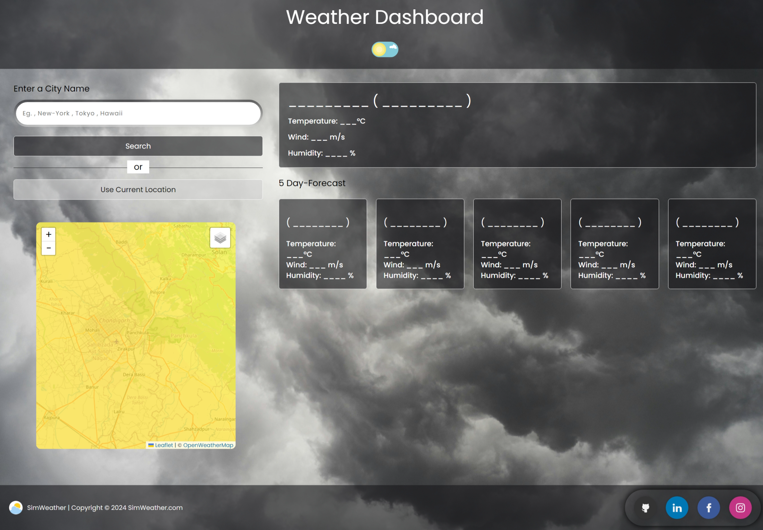

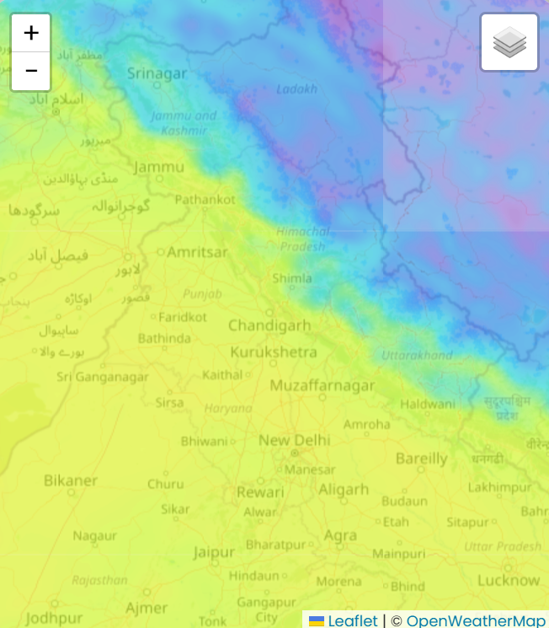

**CONCLUSION**

Our journey in creating this project transcends mere academic pursuit; it is a visionary endeavour aimed at addressing real world challenges. This project has not only honed our technical skills but also instilled a profound sense of responsibility towards delivering practical solutions for users. We encountered and overcame numerous obstacles, transforming each challenge into an opportunity to innovate and enhance our website’s functionality.

Though we have accomplished significant milestones, there remains much to be done . the essence of life lies in perpetual growth and learning. This principle drives us to continuously seek improvement, never ceasing to expand our knowledge and upgrade our capabilities. Our project reflects this ethos , embodying our commitment to relentless progression and innovation.

Looking ahead, we are dedicated to elevating the user experience by integrating advanced Javascript functionalities and robust API connections. These enhancements will significantly improve the accuracy and efficiency of weather updates, ensuring that our users receive the most reliable and timely information possible.

In essence our project represents a fusion of academic rigor and visionary thinking. It is a testament to our dedication to excellence and our unwavering belief in the importance of continuous learning and growth. As we move forward , we remain committed to refining our systems incorporating user feedback and exploring new technologies . It is an ongoing quest of innovation and excellence, driven by a passion for learning and a desire to make a meaningful impact on the lives of users.

**REFERENCES USED**

* **HTML [[1](https://www.w3.org/html/)]**
* **CSS [**[**2**](https://www.w3.org/Style/CSS/)**]**
* **JAVASCRIPT [**[**3**](https://developer.mozilla.org/en-US/docs/Web/JavaScript)**]**
* **YOUTUBE [**[**4**](https://www.youtube.com/)**]**
* **Uiverse.io [[5](https://uiverse.io/)]**
* **GOOGLE FONTS [**[**6**](https://fonts.google.com/)**]**
* **IDEA/SOURCE CODE [**[**7**](https://www.codingnepalweb.com/weather-app-project-html-javascript/)**]**
* **Open Weather Map DOCS [**[**8**](https://openweathermap.org/guide)**]**

**THE END**